Handout no. 14
Name | M.Umar Saleem, M.Usama, Abdul Jabbar
Reg. No | 2019-EE-356,366,376
Marks/Grade

EXPERIMENT # 14
Modeling of Frequency Relay in MATLAB/ Simulink for Generator line Protection
Objective:
At the end of this lab session students will be able to

- Understand the working of frequency relay.
- Model frequency relay in MATLAB/Simulink.
Introduction:
Frequency variations in the system occur due to the variation in the prime mover speed. In a large inter-connected stable system frequency variations are rare. Because a generator unit
connected to a large stable system cannot operate at higher or lower frequency than the system
frequency. But a smaller system or a generator working alone is prone to frequency variations due to the variations in load.

This abnormal condition is not very dangerous for the system. So frequency relay sense the abnormal condition and activate alarm and if this condition persist for a long time then relay
operates the circuit breaker.
Over-Frequency:
This condition is due to the increase in speed of prime mover. On the generation site this is protected by the over-speed device. An over-frequency relay can be used as backup to mechanical devices. Again, if the unit is connected to a stable system, the generator cannot operate above the system frequency. However, if the system is dynamically unstable over-frequency relays can alert the operator. In general, the governing devices will protect the unit from over-speed. But for reliable system all system conditions must be addressed.

Under-Frequency:
While no standards have been established for abnormal frequency operation of generators, it is recognized that reduced frequency results large flux, saturation of magnetic material and large magnetization current. Therefore, operation at reduced frequency should be at reduced kVA or kV.
Operating precautions should be taken to stay within the short-time thermal ratings of the generator rotor and stator. Under-frequency is a system condition that affects the turbines and the
transformers more than the generator.

Frequency Relay:
The frequency relay activates alarm or isolates the generator in the case when frequency deviates from the allowable limits. As mentioned earlier the over and under frequencies are produced in a power system due to sudden change in load or generation. Over frequency can occur due to isolation of a large load by tripping of a transmission line. Under frequency can occur due to loss of one or more generating sources in a heavily loaded power system.

Laboratory Task:
Implement a frequency relay that protects the system in over-frequency and under-frequency
conditions.

Procedure

Step 1:
Draw a power system having a three phase programmable source, three phase circuit breaker, three-phase VI measurement unit and three phase RLC series load. Connect the blocks as shown below.

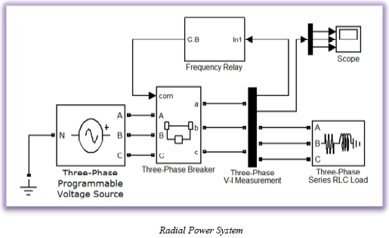

Set the properties of each block as mentioned below. Keep all other parameters as it is.

System Frequency: 50 Hz
Total Simulation Time: 0.5 s
Solver: Ode23tb (stiff/TR-BDF2)
Solver reset Method: Robust

Three phase programmable voltage source:
Voltage (Phase to Phase): 11e3 V
Frequency: 50
Time variation of: Frequency
Type of variation: Step
Step magnitude: 0
Variation timings: [0.18 0.4]

Three-Phase Breakers:
Initial status of breakers: closed

Three-Phase Series RLC Load:
Configuration: Y grounded
Nominal voltage: 11e3
Active Power (W): 100e6
Inductive reactive power: 100 VAR
Capacitive reactive Power: 0 VAR

Step 2:

In subsystem “Frequency Relay”, connect the blocks as shown in the diagram and set the parameters of all the blocks given in the diagram as specified below. To access the different blocks in the MATLAB SIMULINK library their full path have been given against their names.

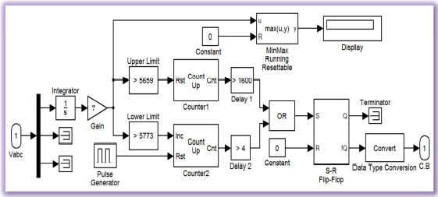

Integrator: (Simulink >> Commonly Used Block)

Initial condition: 0

This block is used to find the area under the curve. The area under the sinusoidal wave depends upon the frequency. Because with the increase in frequency wave shrinks on time axis and its area decreases and vice versa. It means the frequency of system can be judged from the area under the curve. Observe the output of integrator on ‘scope’ along with the sinusoidal waveform.
Also draw these waveforms in the space given below.

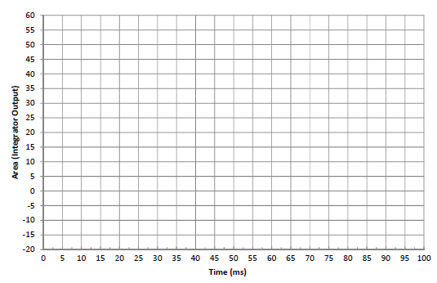

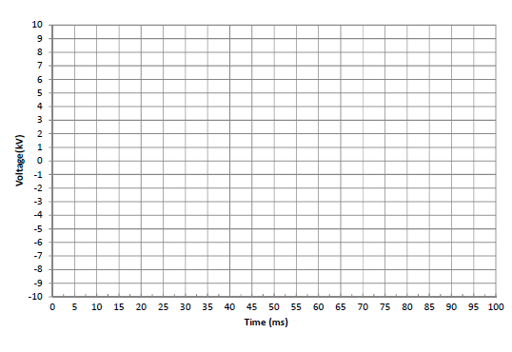
Gain: (Simulink >> Commonly Used Block)

This block is used to amplify the difference between the areas at two different frequencies. To set the value of gain, follow the instructions given below.

For all the students, from Reg. No. 1 to 5 gain is 50 times of their roll number, from Reg.
No. 6 to 25 gain is 10 times of their roll numbers, from Reg. No. 26 to 50 gain is 5 times of their
roll numbers and for the rest of the students gain is equal to their roll number.

Gain = 70

Sample time: 50e-6

MinMax Running Resettable: (Simulink >> Math Operations)
Function: max

This block is used to determine the maximum value of input signal. It holds a value unless it is reset or some new higher value replaces the older one.

Display: (Simulink >> Sinks)
Format: bank

Compare To Constant (Upper Limit & Lower Limit): (Simulink >> Logic and Bit Operations)

To set the ‘constant value’ of these blocks run the simulation of the system at lower and upper limits of frequency by setting the frequency of ‘Programmable source’ to 49 Hz and 51 Hz
respectively, and observe the output of gain on ‘Display’. During this simulation keep the circuit
breaker permanently closed by applying a constant ‘1’ on its ‘com’ input. Note down the observations in the space given below. Output of ‘Gain’ at

49 Hz: ……4050…………, 50 Hz: ………0………., 51 Hz: …3891……..

Upper Limit (51 Hz): …4050………

Lower Limit (49 Hz): …3891………...

Operator: ‘>’ (greater than)

There is an inverse relation between frequency and area under the curve.

Also note down the output on the ‘Display’ block for the following frequencies and draw a plot
between frequency and corresponding area under the curve.

Frequency | 45 | 46 | 47 | 48 | 49 | 50 | 51 | 52 | 53 | 54 | 55
Area (Max) |  | 4314 | 4223 | 4135 | 4050 | 3969 | 3891 | 3816.94 | 3744

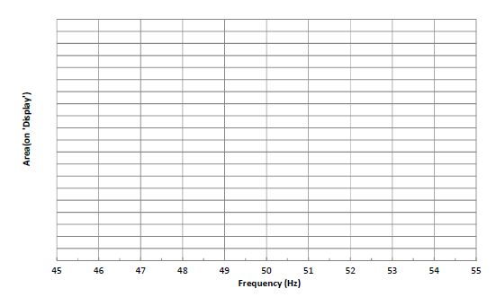

Counter (s): (Signal Processing Blockset >>Signal Management >> Switches and Counters)

Counter1:
Count Direction: Up
Count Event: Free running
Count Size: User defined
Max. Count: 1e6
Initial Count: 0
Output: Count
Reset input: Check this option
Sample Time: 50e-6

Counter2:
Count Direction: Up
Count Event: Rising edge
Count Size: User defined
Max. Count: 1e6
Initial Count: 0
Output: Count
Reset input: Check this option

Pulse Generator: (Simulink >> Sources)

Pulse type: Time based
Time: Use simulation time
Amplitude: 1
Period: 0.1
Pulse width (%): 1
Time delay (sec) 0.099
Set the proper initial condition of ‘S-R Flip-Flop’

Step 3:

Simulate the system in following conditions by setting the parameters of ‘Three-Phase
Programmable Voltage Source’.

Frequency (in all conditions): 50 Hz

Normal Condition:
Step magnitude: 0

Over Frequency:
Step magnitude: 1.5

Under Frequency:
Step magnitude: -1.5

Challenging Task:
There is a flaw in this logic implementation of frequency relay. As this relay calculate the area under the curve of voltage waveform to determine the frequency of voltage, any variation in the
magnitude of the voltage will cause a mal operation of the relay. In practical systems, these variations are quite common due to different loading conditions and transients in the system.

Frequency relay logic should be independent from the variations in the voltage magnitude. So make appropriate changes in this logic to make it robust against the variation in voltage.

Assignment:
-  Modify your frequency relay to add four additional inputs as mentioned blow.
1. Upper frequency limit
2. Lower frequency limit
3. Time Delay
4. Reset

Hint: reset the integrator at the end of each cycle of voltage to make its output zero at the start of
next voltage cycle. Otherwise reset will not work properly.

- Relay must accept the frequency limits in Hz and time delay in seconds.
- Energize the system using ‘reset’ on the start and after the fault clearance.
- Attach printout of Simulink model, output on scope (voltage only) for time delays (0.04s & 0.1s) and comprehensive details of modifications and the settings of the blocks (computer typed). Values of all the constant blocks and gain must be clear in the snapshot of model.
- Your assignment should be complete in all respects.

Circuit Diagram:
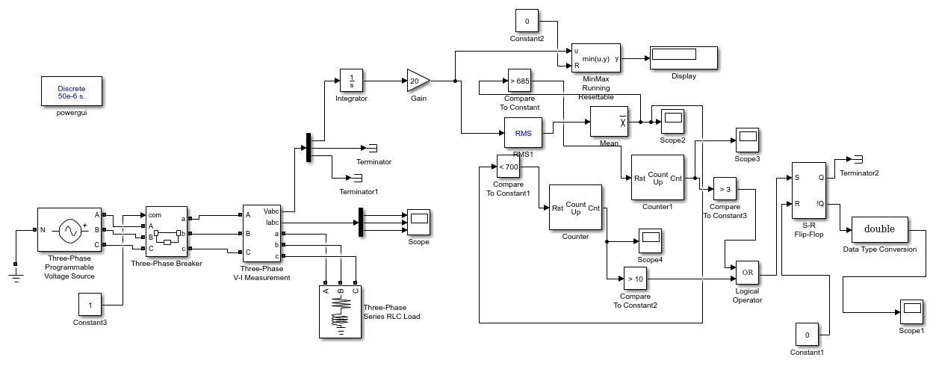
Fig 14.1

Under Normal Condition Without Frequency fault:
Relay Graph:
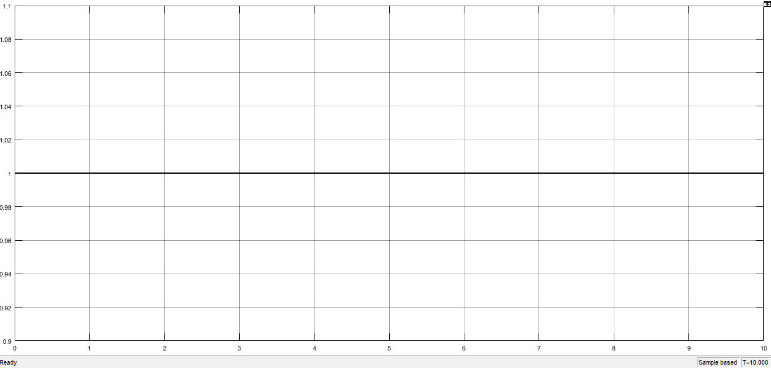
Fig 14.2

Voltage Graph:
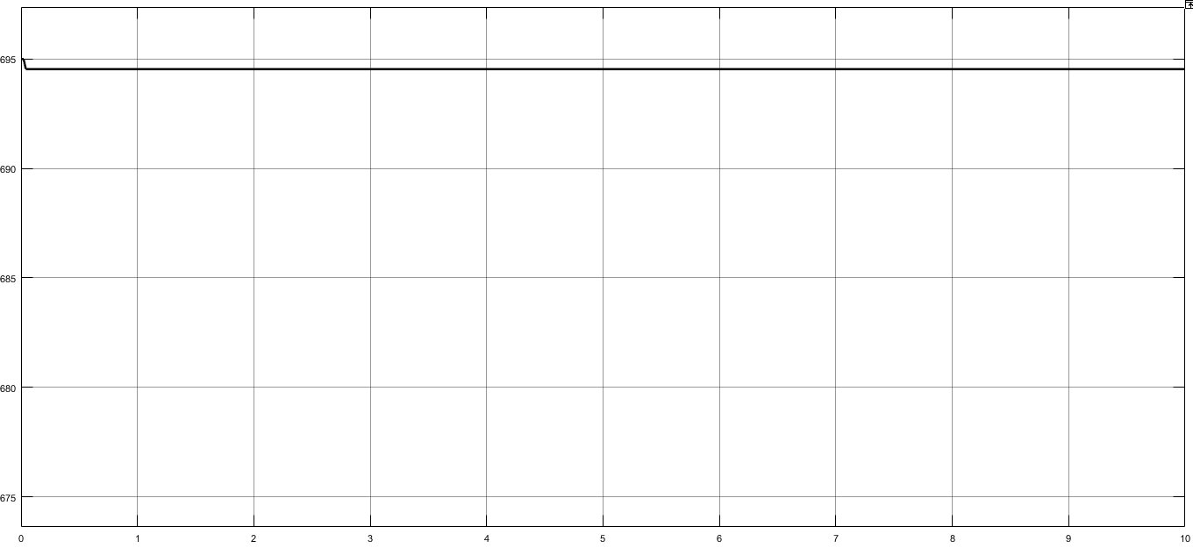

Counter Signal:
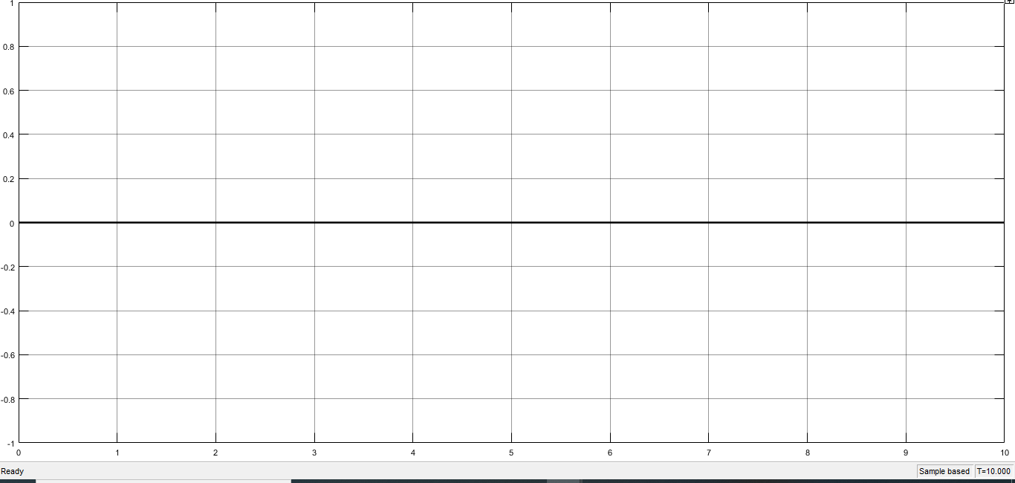
Fig 14.3

Underfrequency Condition:
Relay Signal:
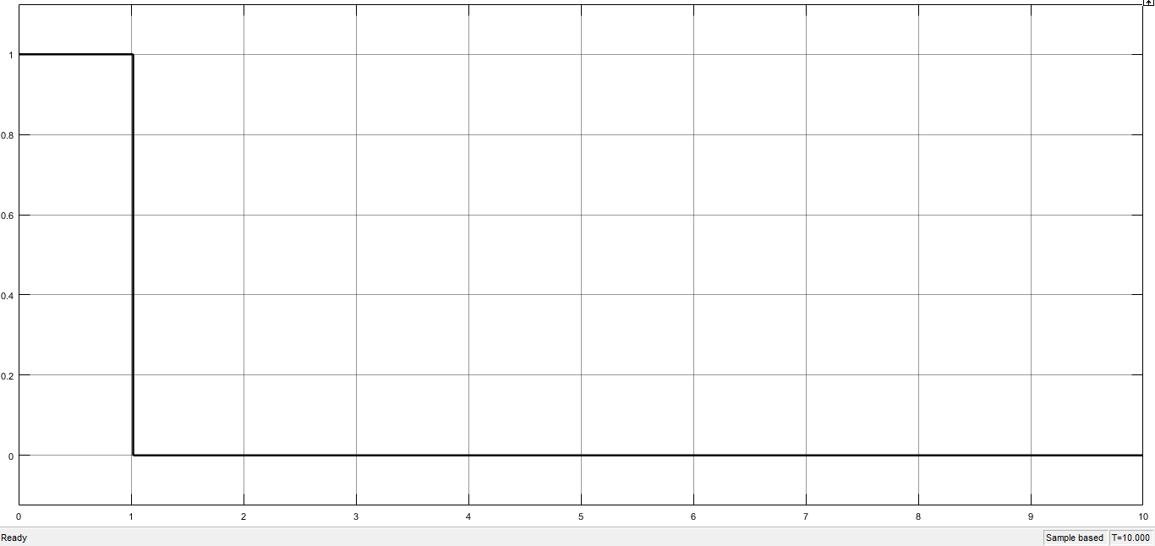
Fig 14.4

Voltage Graph:
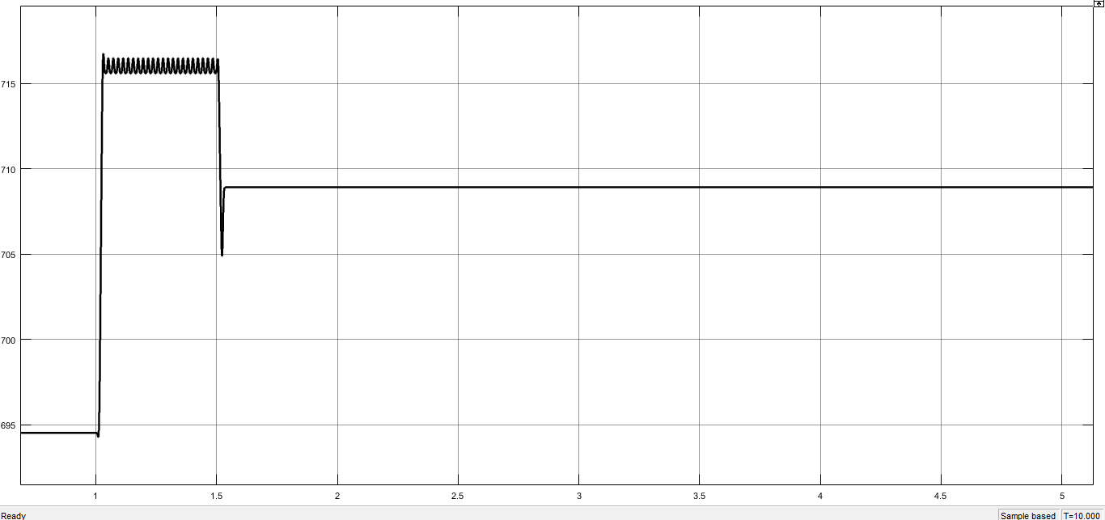
Fig 14.5

Counter Signal:
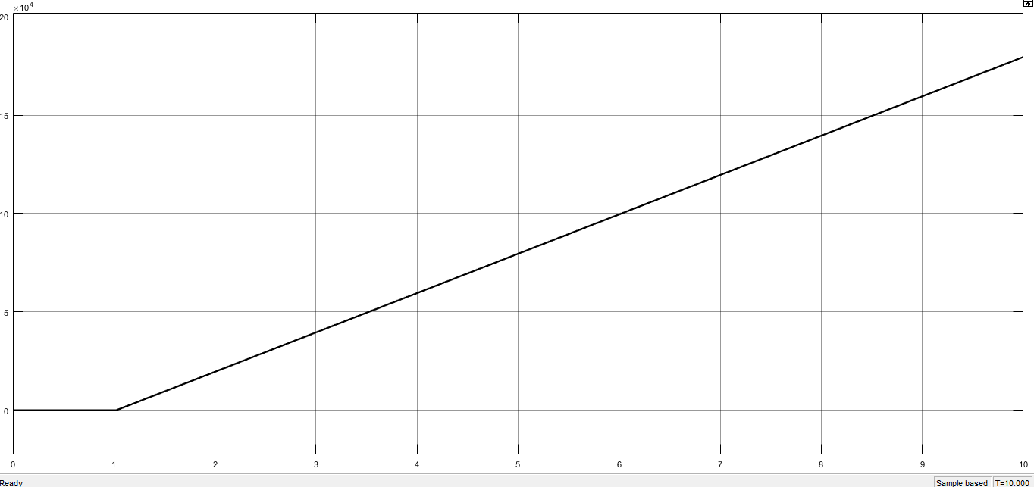
Fig 14.6

Over frequency Condition:
Voltage Signal:
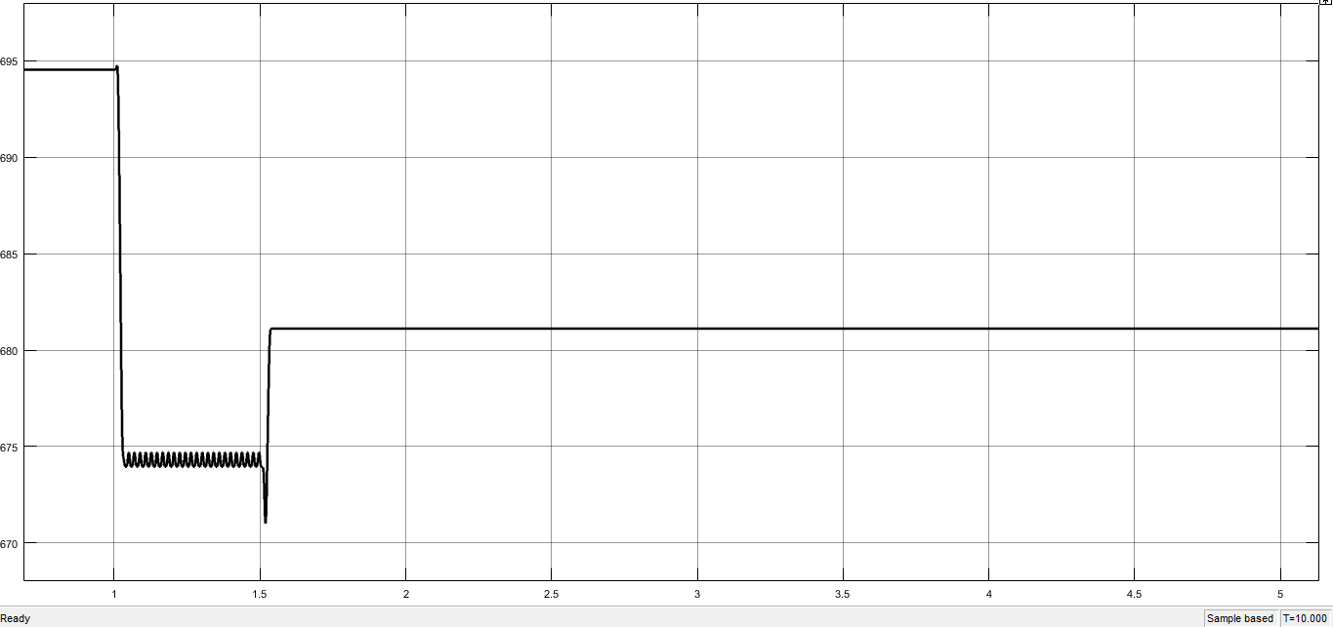
Fig 14.7

Relay Signal:
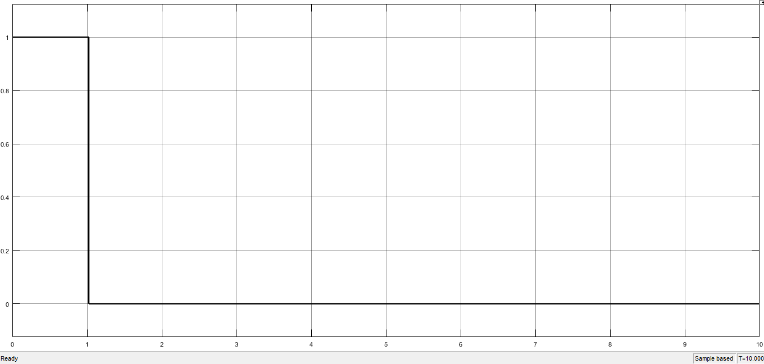
Fig 14.8

Counter Signal:
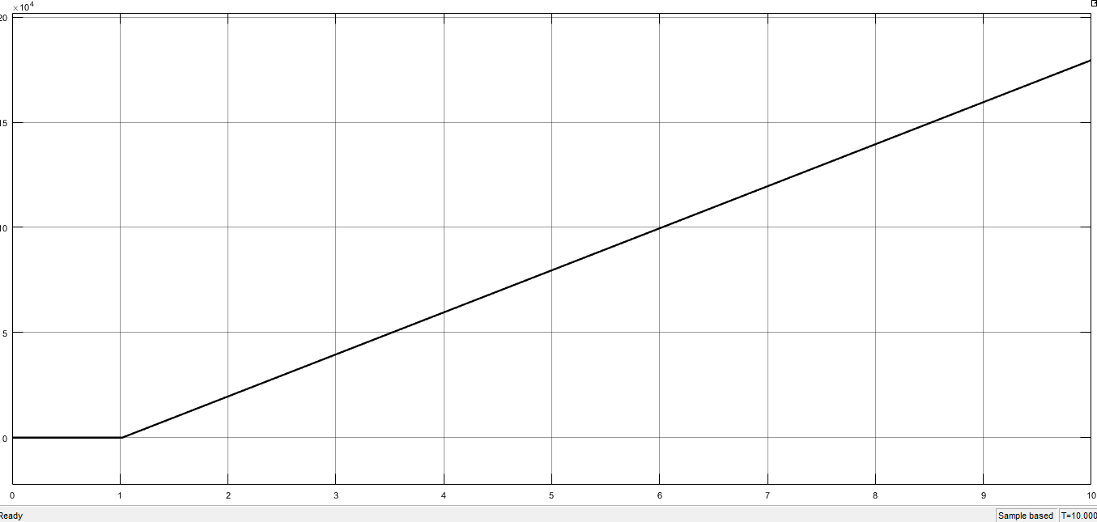
Fig 14.9

Conclusion:

In this lab we have learnt about the working of frequency relay. And designed a Model of frequency relay in MATLAB/Simulink.
We have learnt that the Frequency variations in the system occur due to the variation in the prime mover speed. In large inter-connected stable system frequency variations are rare. Because a generator unit connected to a large stable system cannot operate at higher or lower frequency than the system frequency. We have also understood that a smaller system or a generator working alone is prone to frequency variations due to the variations in load.
We explored that this abnormal condition is not very dangerous for the system. So, frequency relay sense the abnormal condition and activate alarm and if this condition persist for a long time, then relay operates and opens the circuit breaker.
We have learnt over frequency conditions and this condition is due to the increase in speed of prime mover. On the generation site this is protected by the over-speed device. An over frequency relay can be used as backup to mechanical devices. Again, if the unit is connected to a stable system, the generator cannot operate above the system frequency.
We have learnt that no standards have been established for abnormal frequency operation of generators, it is recognized that reduced frequency results large flux, saturation of magnetic material and large magnetization current. Therefore, operation at reduced frequency should be at reduced kVA or kV.
We designed and analyse over frequency and under frequency relay and established time delay settings using counters and change the operating times of the relay.

